
Assessment

Course -Btech CSE Robotics and AI
Discipline - SOET
Program - Nand -to-Tetris
Name - Ajitesh Singh Gusain
Faculty – Dr. Ayyala kishore Ajay Kumar
Sem - 3
Course code - ETCCNT301

Lab 1 - Question 1: Implementation of Elementary Logic Gates Using Universal NAND Gates

1. Objective & Theoretical Background
The objective of this section is to construct basic logic gates (NOT, AND, and OR) using exclusively NAND gates. In digital circuit design, the NAND gate is a universal gate, meaning any Boolean logic function can be implemented using combinations of NAND gates alone.

2. Gate Implementations & Analysis
A. NOT Gate (Inverter)
- Concept: A NOT gate flips a single binary input ($0→1$ and $1→0$). A NAND gate outputs 0 only when both inputs are 1. By tying both input pins of a NAND gate together to the same input signal, the gate acts as an inverter.
- Boolean Expression: $\text{out}=\overline{\text{in}}\text{=}∈NAND∈$
- HDL Code:
Code snippet
CHIP Not {
IN in;
OUT out;

PARTS:
Nand(a=in, b=in, out=out);
}
- Logic Diagram Setup:
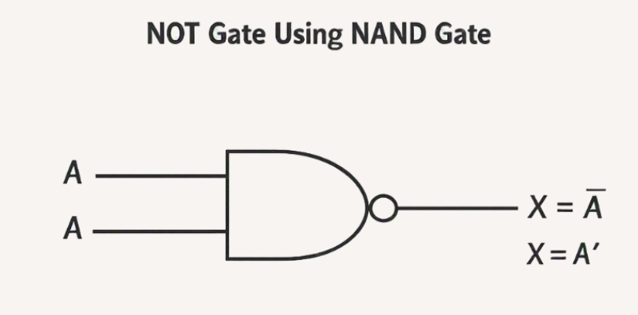

Y = (A·A)̅
= A̅
So only 1 NAND gate is required.
Simulation Verification: Ran Not.tst in the Hardware Simulator. The script passed all steps ($\text{=}0→out\text{=}1$, $\text{=}1→out\text{=}0$).
Truth table
Input (in) | NAND Input a | NAND Input b | Output (NOT(in))
0 | 0 | 0 | 1
1 | 1 | 1 | 0

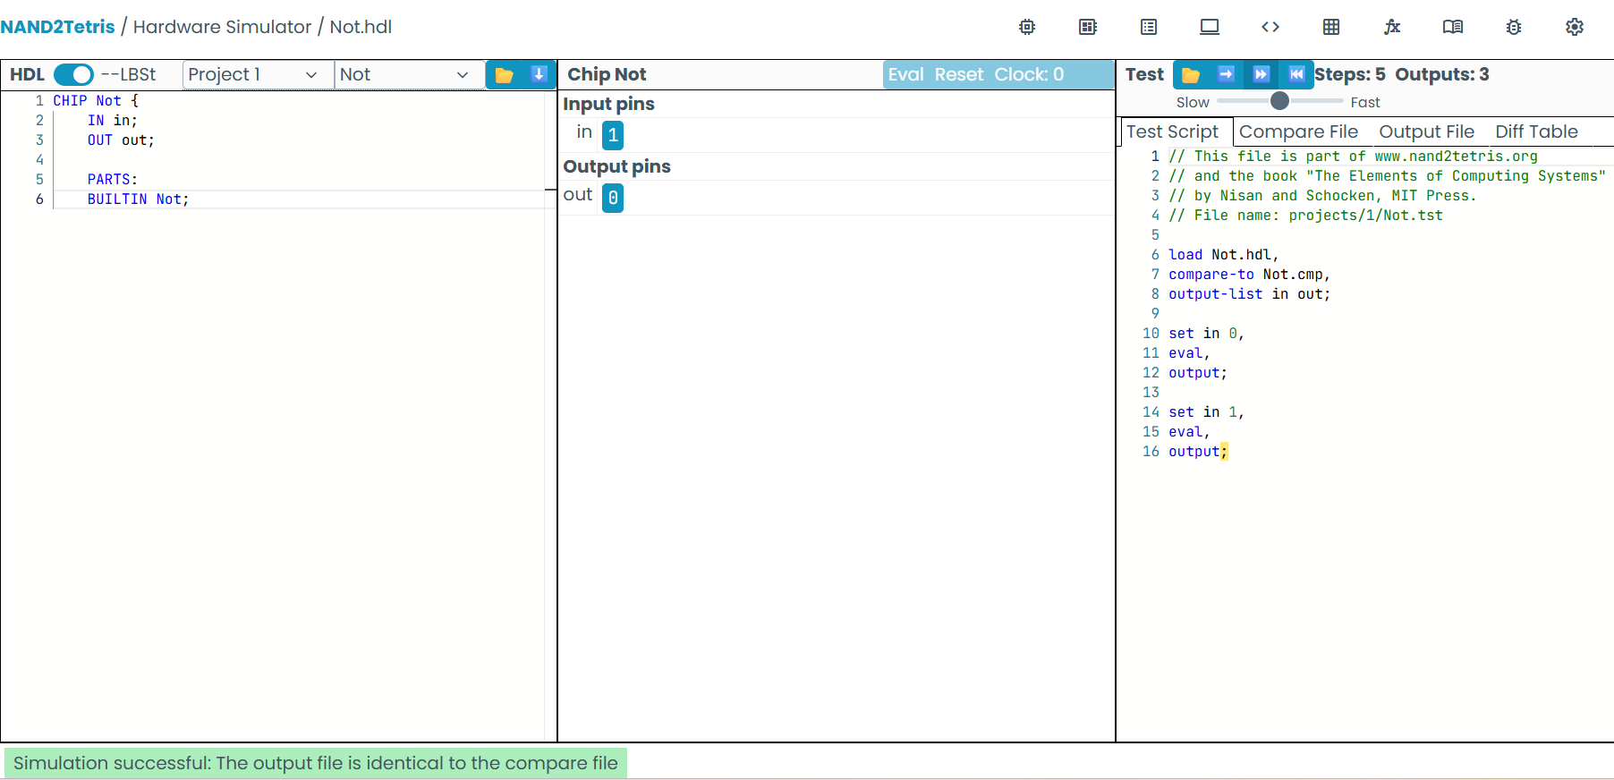

B. AND Gate
- Concept: An AND gate outputs 1 only when both inputs a and b are 1. A standard NAND gate outputs 0 when both inputs are 1. Passing the output of a NAND gate through a NAND-based inverter flips the result back to positive AND logic.
- Boolean Expression: $\text{out}\text{=}a⋅b\text{=}\overline{\overline{a⋅b}}=\left(aNANDb\right)NAND\left(aNANDb\right)$
- HDL Code:
Code snippet
CHIP And {
IN a, b;
OUT out;

PARTS:
Nand(a=a, b=b, out=nandOut);
Nand(a=nandOut, b=nandOut, out=out);
}
Logic Diagram Setup:
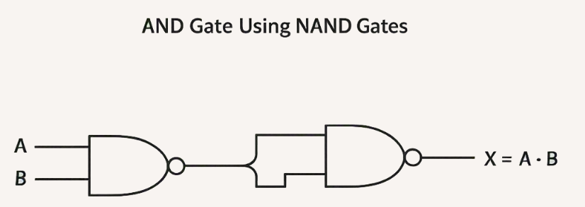

Y = [ (A·B)̅ · (A·B)̅ ]̅
Y = A·B
- Simulation Verification:
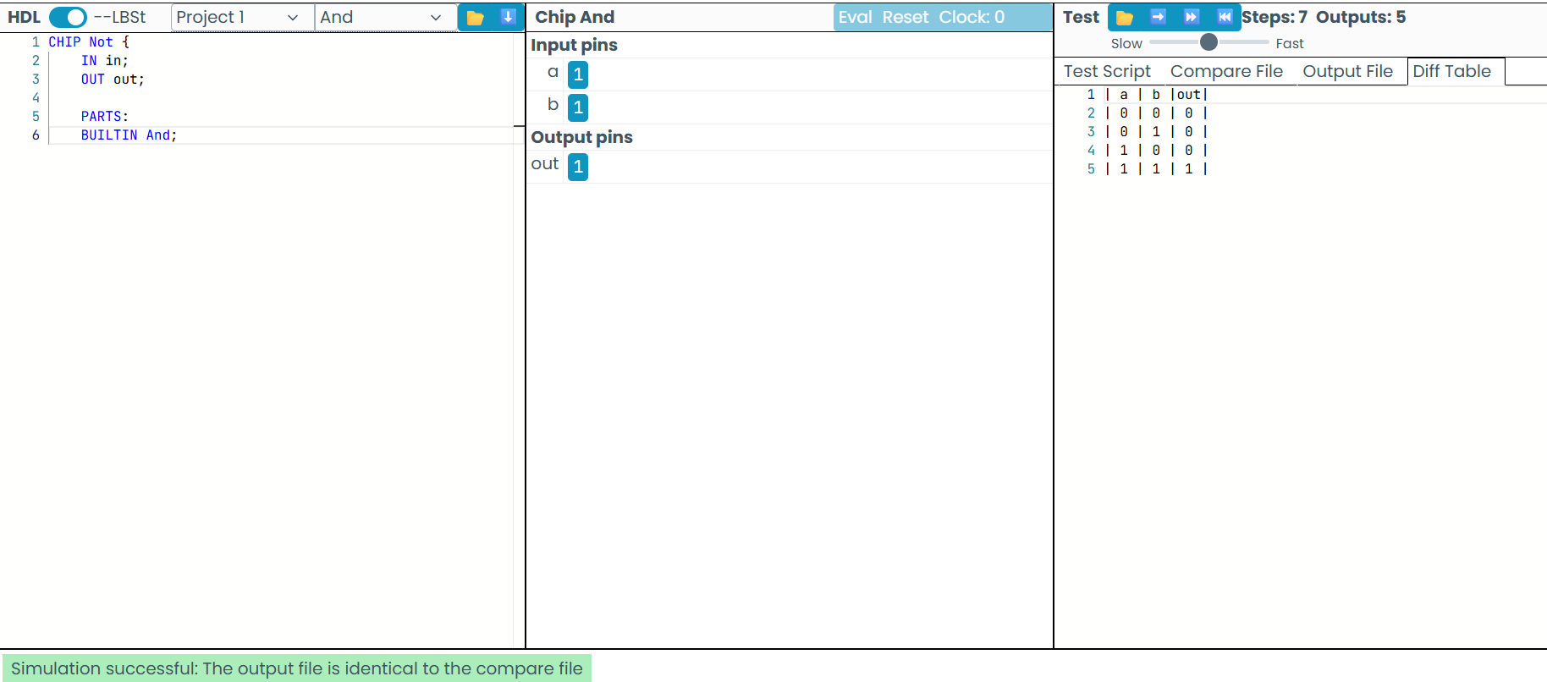
Truth table
Input a | Input b | Stage 1 (nandOut) | Stage 2 / Final Output (out)
0 | 0 | 1 | 0
0 | 1 | 1 | 0
1 | 0 | 1 | 0
1 | 1 | 0 | 1

C. OR Gate
- Concept: An OR gate outputs 1 if at least one input is 1. According to De Morgan’s Law ($\text{out}\text{=}a\text{+}b\text{=}\overline{\overline{a}⋅\overline{b}}$), an OR operation is built by inverting inputs a and b individually using NAND gates, then passing those inverted signals into a final NAND gate.
- Boolean Expression: $\text{out}\text{=}a\text{+}b\text{=}\overline{\overline{a}⋅\overline{b}}=\left(aNANDa\right)NAND\left(bNANDb\right)$
- HDL Code:
Code snippet
CHIP Or {
IN a, b;
OUT out;
PARTS:
Nand(a=a, b=a, out=notA);
Nand(a=b, b=b, out=notB);
Nand(a=notA, b=notB, out=out);}
Logic Diagram Setup:
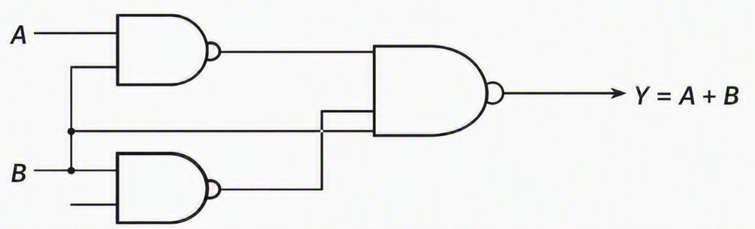
- Simulation Verification:

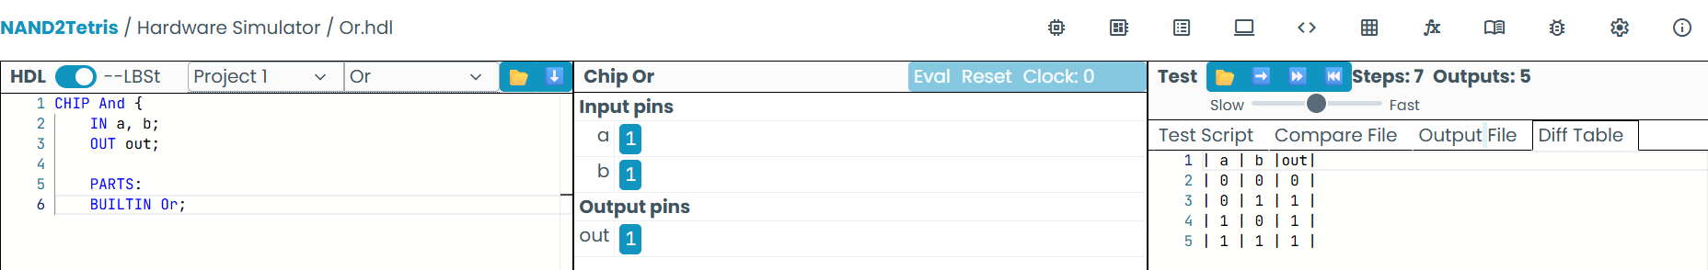

Truth table
Input a | Input b | Stage 1 (notA) | Stage 2 (notB) | Stage 3 / Final Output (out)
0 | 0 | 1 | 1 | 0
0 | 1 | 1 | 0 | 1
1 | 0 | 0 | 1 | 1
1 | 1 | 0 | 0 | 1

